 | Wantirna Primary School
 | Homework Policy
Last Review Date:  November 2025 | Due for Next Review:  November 2029
Included on Website:  Yes | Authorised (Principal):

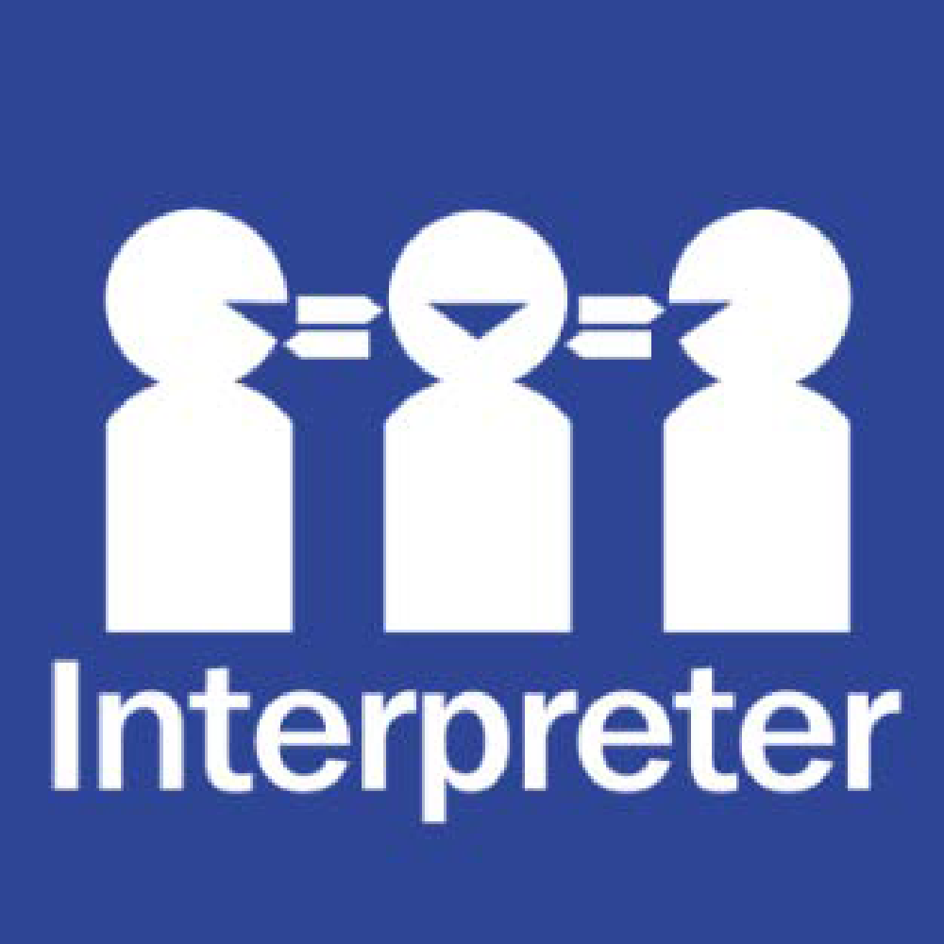
Help for non-English speakers
If you need help to understand the information in this policy, please contact Wantirna Primary School on (03) 9801 1938 or wantirna.ps@education.vic.gov.au

PURPOSE

To outline to our school community the Department’s and Wantirna Primary School’s policy requirements relating to homework.

SCOPE

This policy applies to students in all year levels and staff responsible for setting and monitoring homework at Wantirna Primary School.

RATIONALE

Wantirna Primary School has developed this Homework Policy in consultation with the School Council to support student learning and wellbeing by:
- providing opportunities for students to review, revise and reinforce newly acquired skills
- providing opportunities for students to apply new knowledge
- providing opportunities for students to prepare for future lessons
- encouraging students to enrich or extend knowledge individually, collectively and imaginatively
- fostering good lifelong learning and study habits
- supporting learning partnerships with parents/carers.

DEFINITIONS

Homework is tasks assigned to students by teachers that are meant to be carried out during non-school hours.

POLICY

At Wantirna Primary School all homework set by teachers will be:
- purposeful
- curriculum-aligned
- appropriate to students’ skill level and age
- designed to help students develop as independent learners
- monitored by the teacher
- where appropriate, provide opportunities for parents/carers to partner in their child’s learning.

Homework at Wantirna Primary School is personalized across the year levels and for individual students. Homework may include:

- completing consolidation exercises for mathematics
- completing science investigation exercises
- making or designing an artwork
- practising spelling words
- practising words/phrases learnt in Auslan
- reading background material for a subject
- reading English texts prior to class discussion
- reading for pleasure
- researching topics associated with set class work
- revising/preparing for tests
- applying new skills to home context such as:
  - planning and cooking food, including following a recipe
  - helping to plan a day trip or holiday, including timings, directions and costs
  - reviewing their favourite film or book
  - writing a diary entry
- engaging with parents in learning activities such as:
  - rehearsing a presentation with parent/carers, and seeking their feedback
  - interviewing a family member as part of a research project.

SHARED EXPECTATIONS AND RESPONSIBILITIES
Homework is a shared responsibility between the school, teachers, students and their parents/carers. In order to get the most out of homework tasks, it is important that everyone understands their obligations and responsibilities.
Responsibilities and expectations for leaders at Wantirna Primary School are to:
- advise teachers, students and parents/carers of homework expectations at the beginning of the school year and provide them with access to the homework policy.

Responsibilities and expectations for teachers at Wantirna Primary School are to:
- set homework that is curriculum-aligned and appropriate to the student’s skill level and age
- ensure homework tasks are purposeful – this means they are deliberately designed and planned to support student learning (so, they are not ‘busy work’ or where students ‘finish off’ work they did/could not complete in class)
- assess homework and provide timely and practical feedback
- ensure the amount of homework set supports a student to engage with a range of recreational, family and cultural activities outside of school hours
- offer opportunities for families to engage in their children’s learning.

Responsibilities and expectations for students are:
- being aware of the school’s homework policy
- discussing homework expectations with their parents/carers
- accepting responsibility for the completion of homework tasks within set time frames
- following up on comments made by teachers
- seeking assistance when difficulties arise
- organising their time to manage home obligations, participation in physical activity and sports, recreational and cultural activities and part-time employment (for older students).

Responsibilities and expectations for parents/carers are:
- ensuring there is a balance between the time spent on homework and recreational, family and cultural activities
- talking to teachers about any concerns they have about the homework
- discussing homework with their child in their first language, if English is not the main language spoken at home,
- in dialogue, linking homework to:
  - previous experiences the child and/or parent/carer may have had
  - family culture(s), history(ies) and language(s)
  - relevant services, clubs, associations and community.
- ensuring there is a quiet study area for their child to complete homework.
- If a parent or carer chooses for their child not to participate in home learning tasks, it is their responsibility to contact the child’s teacher and complete the required exemption form.

SUPPORT FOR STUDENTS AND PARENTS/CARERS

Wantirna Primary School understands that students have different learning strengths, preferences and interests and may approach learning activities and homework differently. If parents/carers are concerned their child may not understand the homework tasks that have been set or is spending a long period of time completing their homework, we encourage parents/carers to speak to their child’s teacher.

COMMUNICATION
This policy will be communicated to our school community in the following ways:
- Available publicly on our school’s website (Included in staff handbook/manual
- Reminders in our school newsletter
- Discussed at annual staff briefings/meetings
- Discussed at parent information nights/sessions
- Hard copy available from school administration upon request

RELATED POLICIES AND RESOURCES
- Homework – Department Policy

POLICY REVIEW AND APPROVAL
Policy last reviewed | November 2025
Consultation | Teaching Staff
Approved by | Principal
Next scheduled review date | November 2029

